|  |
| --- |
| Welcome to Word  6 tips for a simpler way to work |

# Quick access to commands

At the top of your document, the Quick Access Toolbar puts the commands you use frequently just one click away.

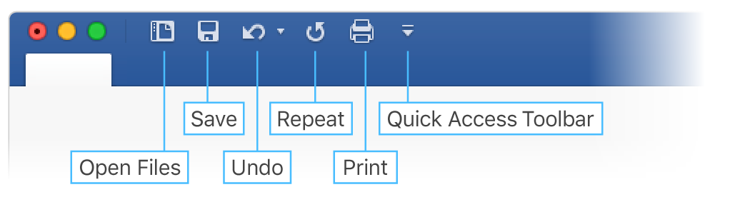

If the commands currently shown aren’t quite what you need, customize the Quick Access Toolbar.

Try it:

Click the down-arrow button and click command names to add or remove them from the Quick Access Toolbar.

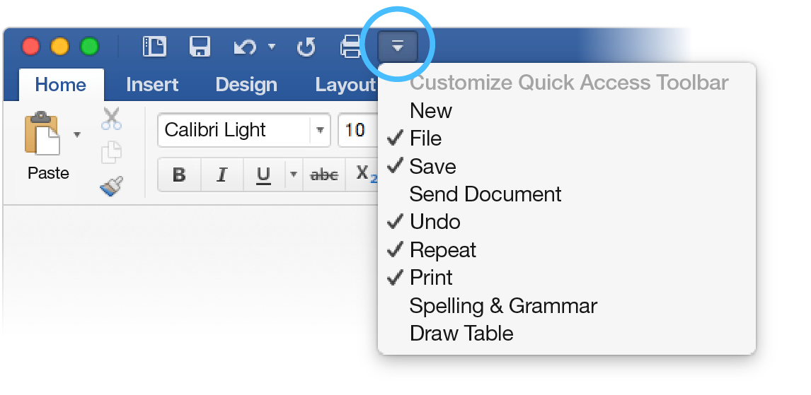

# Look professional, your way

In this document, styles like **Heading 1** and **Title** have been applied to text (**Home** tab, **Styles** gallery). That lets you quickly overhaul the look of the whole document.

Try it:

1. On the **Design** tab, click the different **Style Sets** and watch the formatting change automatically.  
   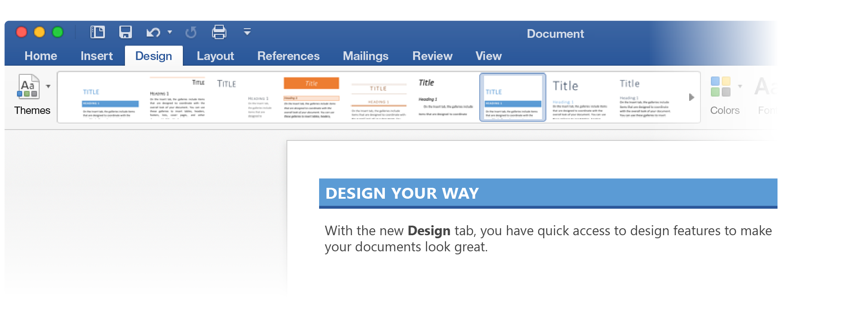
2. Go to **Themes** and watch how colors and fonts change with the various choices.  
   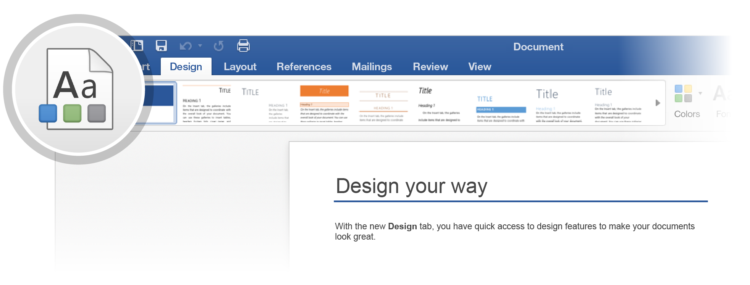
3. The **Design** tab also provides choices for fine-tuning colors, fonts, or paragraph spacing. You can also add a watermark or page border, or change the color of the page.  
   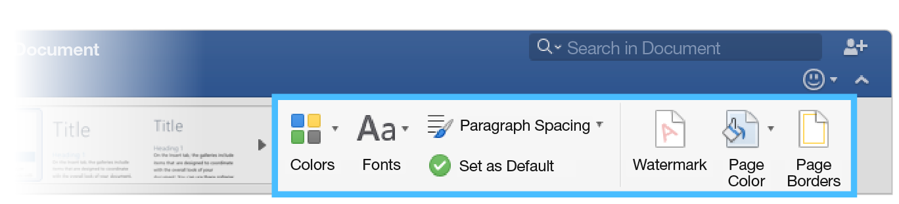

# Edit pictures without leaving Word

When it comes to pictures, Word includes options for adjusting color, cropping, removing the background, applying artistic effects, and more.

Try it:

1. Select this photograph of an otter:  
   
2. Click **Picture Format**, and then click **Artistic** **Effects** and select an effect, like **Mosaic** **Bubbles**.
3. To see all the formatting options, open the **Format Pane**, on the right side of the app.  
   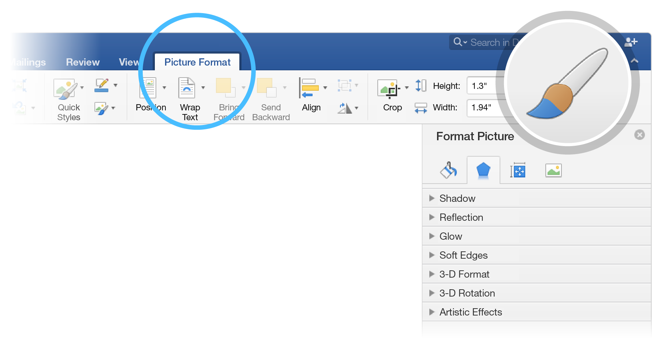
4. If you apply formatting you don’t like, press F1 to undo it, or click **Reset** in the Format Pane to go back to the original picture.

**Hint:** To open the Format Pane quickly, press Command+Shift+1.

# Explore without leaving your doc

**Smart Lookup** brings research from the web directly into Word.

Try it:

1. Select the word “Otter”
2. Go to the Review tab and click **Smart Lookup**  
   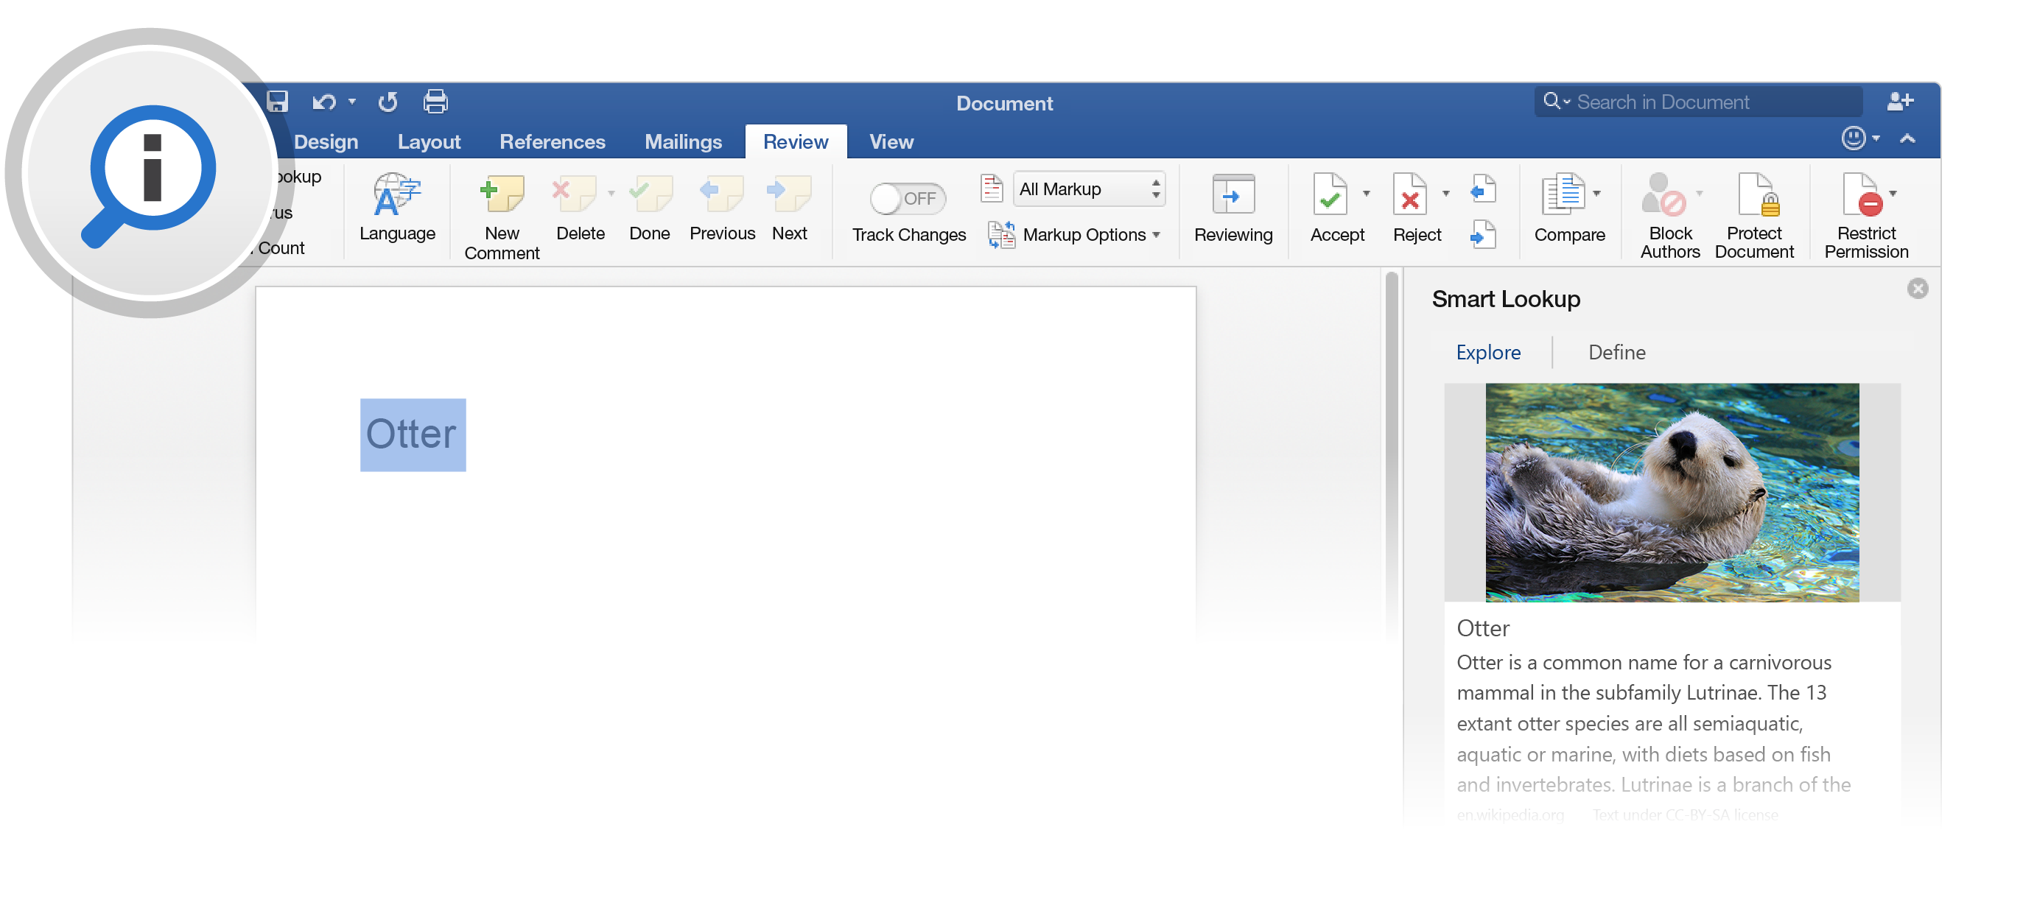

Source: Wikipedia CC-by-SA – <https://en.wikipedia.org>

1. To close out of the **Smart Lookup** pane, click the x at the top of the pane.  
   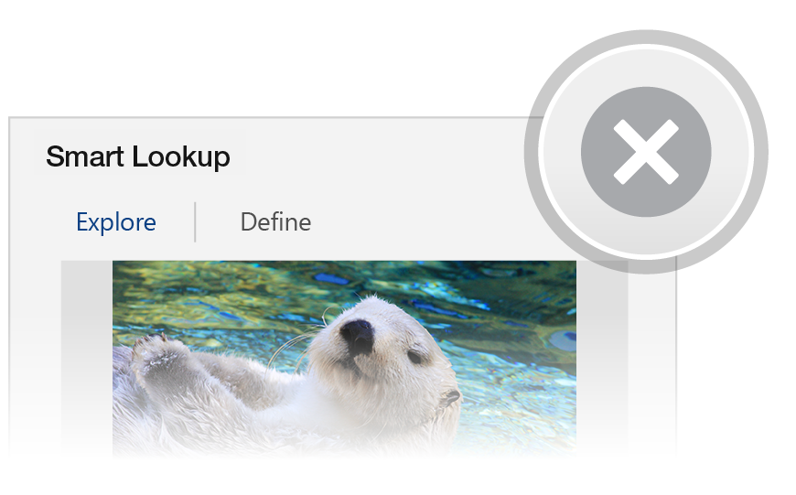

# Designed for teamwork

With your document stored online, your group can work on it together at the same time.

How it works:

1. Save your document in an online location, like OneDrive.
2. Click **Share**.  
   
3. Invite people or send a link so they can edit with you.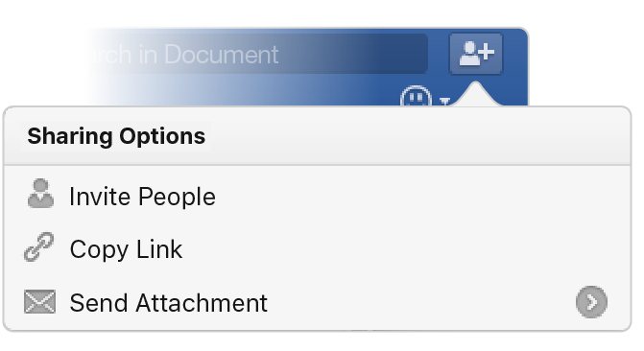

# Give feedback in comments

Comments are threaded, so you can have a conversation right next to relevant text. This is a great way to quickly add your feedback.

Try it:

1. Click somewhere in this paragraph, and then click the **Review** tab.
2. Click **New Comment**, and type something.  
   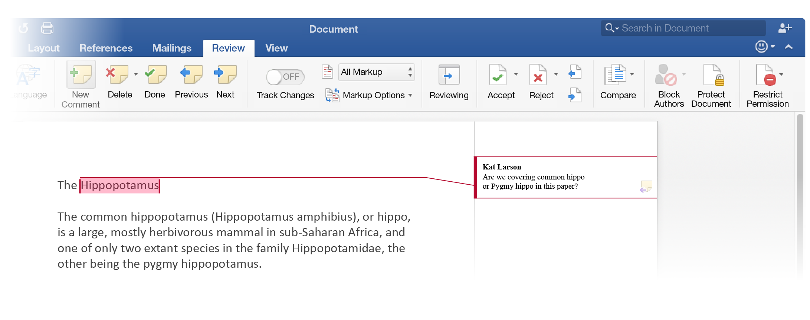
3. Notice that your comment includes a **Reply** button. Use it to respond to a comment.  
   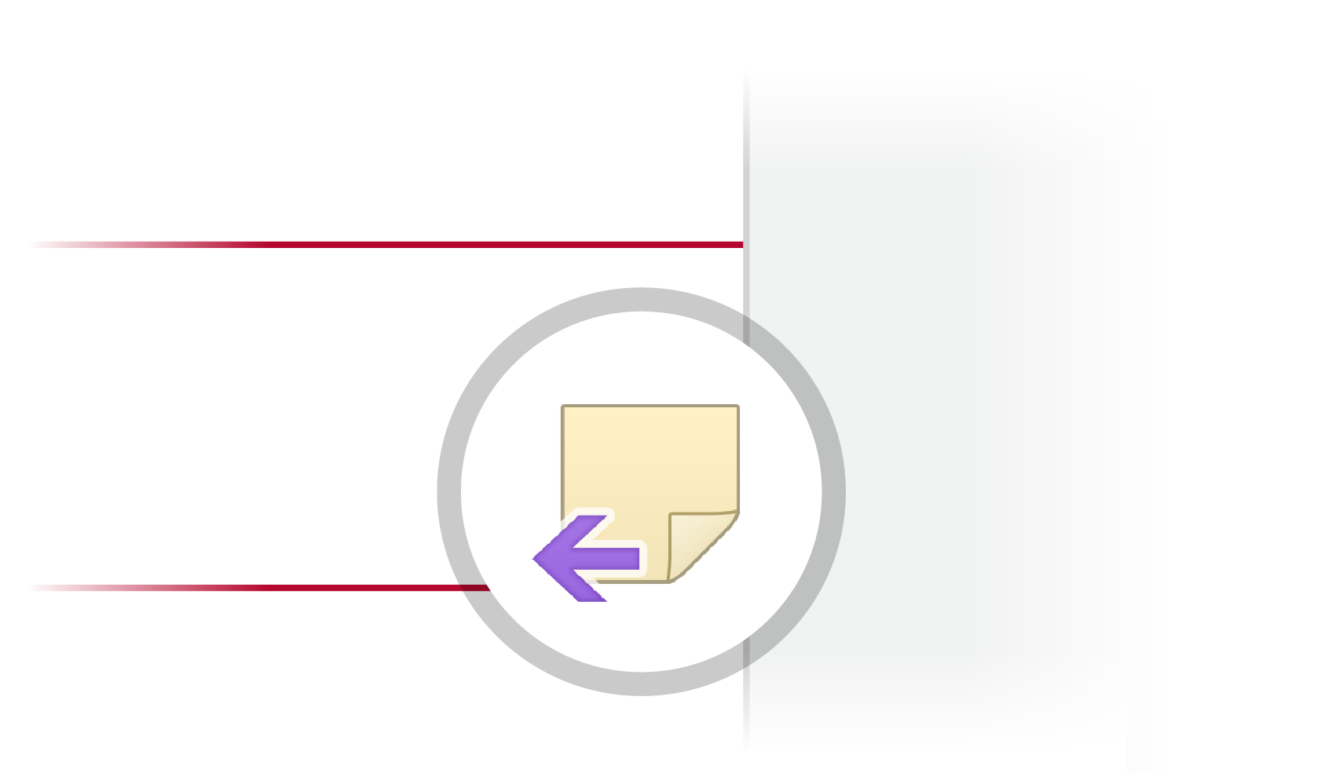

**Hint:** When you’ve taken care of feedback, get the comment out of your way without losing it: Click the comment and then click **Done** on the **Review** tab.

# More questions about Word?

|  |  |  |
| --- | --- | --- |
| Visit the Word team blog. | [Arrow with hyperlink to Word team blog web page](http://go.microsoft.com/fwlink/?LinkId=617174) | |
| Get help with Word for Mac. | | [Arrow with hyperlink to Word for Mac help website](http://go.microsoft.com/fwlink/?LinkId=746226) |